CHAPTER 4
Economic Efficiency, Government Price Setting, and Taxes
- Chapter Summary
- Learning Objectives
- Chapter Outline
Teaching Tips/Topics for Discussion
- Solved Problems
- Solutions to Review Questions and Problems and Applications

1. Chapter Summary
Governments of over 200 cities in the United States have placed ceilings on the maximum rent some landlords can charge for their apartments. Some firms have coaxed governments into imposing price floors, which are legally determined minimum prices that sellers may receive. Another form of government intervention in markets is the imposition of taxes. To understand the economic impact of government interventions in markets, it is necessary to understand consumer surplus and producer surplus.
Consumer surplus is the dollar net benefit consumers receive from buying goods and services at market prices less than the maximum prices they would be willing to pay. In a demand and supply graph, consumer surplus equals the area below the demand curve and above a horizontal line drawn from the price axis to the point on the demand curve that represents the market price. Producer surplus is the dollar net benefit producers receive from selling goods and services at prices greater than the minimum prices they would be willing to accept. In a demand and supply graph, producer surplus is equal to the area above the supply curve and below a horizontal line drawn from the price axis to the point on the supply curve that represents the market price. In a competitive market, the equilibrium price for a good or service occurs at the quantity of product where the marginal cost of the last unit produced and sold is equal to the marginal benefit consumers receive from the last unit bought. Therefore, equilibrium in a competitive market results in an economically efficient level of output. At this same level of output economic surplus, the sum of consumer and producer surplus in this market is maximized.
Some producers who believe an equilibrium price is too low will lobby for government action to set a higher legal price (a “floor price”). Some consumers who believe that an equilibrium price is too high will lobby government to legally require that a lower price (a “ceiling price”) be charged. Although price ceilings and price floors are not common, they have been established in some markets. Price floors were established in agricultural markets in the United States during the Great Depression. Government intervention in agriculture has continued ever since. Although the administration of price floors can be complex, the basic operation of this price control involves a government commitment to maintain a price (for example, $3.50 per bushel of wheat) that exceeds the equilibrium price (for example, $3.00). The price floor reduces the quantity demanded of the product while it encourages producers to increase the quantity supplied. The difference between these two quantities, a surplus, is typically bought by government at the floor price. The result of the price floor is to (a) transfer some consumer surplus that would exist at the equilibrium price to producer surplus and (b) create a “deadweight loss” or a net loss of consumer and producer surplus. The deadweight loss is also the efficiency loss that results from the price floor. Another example of a price floor is the “minimum wage,” which is a legal wage imposed above the equilibrium wage offered in the United States for most occupations. Since most workers earn wages above the minimum wage, this price (wage) floor affects low-skilled and inexperienced workers. Although the economic impact of the minimum wage is similar to that of price floors imposed in other markets (deadweight losses result), economists have disagreed about the extent to which the minimum wage reduces employment.
Price ceilings are found most often in the markets for apartments in various cities; local governments will usually impose this type of price ceiling. In New York City, about 1 million apartments are subject to rent control. A simple description of the impact of a price ceiling on rent (administration of the ceiling will vary by city and over time) is that the quantity demanded at the ceiling price, for example, $1,000 per month, exceeds the quantity supplied. In contrast, if an equilibrium price of, say $1,500, were allowed, the quantity supplied would be greater and the quantity demanded would be less; these two quantities would be equal and there would be no shortage of apartments. The results of the price ceiling are to (a) transfer some producer surplus to consumer surplus and (b) create a deadweight loss or a net loss of consumer and producer surplus. Another possible result of the ceiling is the creation of a “black market” where buyers agree to rent apartments from landlords for greater than the legal price. Because the ceiling reduces quantity supplied, the black market price may exceed the equilibrium price.
A tax on the sale of a good or service also results in a reduction of economic efficiency. For example, if the federal government were to impose a cigarette tax of $1.00 per pack, this would decrease the supply (shift the supply curve of cigarettes to the left, or shift it up by $1.00). The tax results in a loss of consumer and producer surplus. Some of the reduction of consumer and producer surplus becomes government revenue and the rest is a deadweight loss, which is referred to as the excess burden of the tax.
The incidence of a tax is the actual division of the excess burden between producers and consumers in the market. The tax incidence varies depending on how responsive producers and consumers are to the price change caused by the tax.

2. Learning Objectives
Students should be able to:
- Understand the concepts of consumer surplus and producer surplus.
- Understand the concept of economic efficiency, and use a graph to illustrate how economic efficiency is reduced when a market is not in competitive equilibrium.
- Use demand and supply graphs to analyze the economic impact of price ceilings and floors.
- Use demand and supply graphs to analyze the economic impact of taxes.

3. Chapter Outline
Should the Government Control Apartment Rents?
1. Rent control is an example of government regulation of prices. Rent controls (a type of price ceiling) exist in about 200 cities in the United States. Although the rules that govern rent control are complex and vary by city, rent control drives up the demand and price for apartments not subject to the controls.
►Teaching tips: One can assign Solved Problem 4-1 and An Inside Look from this chapter to reinforce students’ understanding of the impact of rent control on the supply and demand for apartments.
Consumer Surplus and Producer Surplus
1. Consumer surplus is the difference between the highest price a consumer is willing and able to pay and the price the consumer actually pays.
2. Producer surplus is the difference between the lowest price a firm would have been willing and able to accept and the price it actually receives.
- Consumer and producer surplus represent the net benefits consumers and producers receive from buying and selling a good or service in a market.
- Price ceilings and price floors reduce the economic surplus (this is consumer surplus plus producer surplus in a given market).
- Marginal benefit is the benefit to a consumer from consuming one more unit of a good or service.
- The height of a market demand curve at a given quantity measures the marginal benefit to someone from consuming that quantity. Consumer surplus refers to the difference between this marginal benefit and the market price the consumer pays.
- Total consumer surplus is the difference between marginal benefit and price for all quantities bought by consumers; this is shown in a demand curve as the area below the demand curve and above the market price.
- Marginal cost is the additional cost to a firm of producing one more unit of a good or service.
- The height of a market supply curve at a given quantity measures the marginal cost of the last unit produced for the producer. Producer surplus refers to the difference between this marginal cost and the market price the producer receives.
- Total producer surplus equals the difference between marginal cost and price for all quantities sold by producers.
►Teaching tips: Consumer and producer surplus are topics many students have difficulty understanding. It may help to ask if they ever bought something they thought was a bargain, or to recall a purchase made by a friend or family member at a price they believed was too high. Consumers benefit from paying the market price rather than the maximum price they would be willing to pay. Since the marginal cost of producing a product increases as more is produced, and price will equal marginal cost for the last unit of output produced and sold in a competitive market, price must be greater than the marginal cost of all other units produced. Consider spending class time reviewing Figure 4-5 and making sure students understand these important topics.
The Efficiency of Competitive Markets
1. When equilibrium is reached in a competitive market, the marginal benefit from the last unit sold will equal the marginal cost of producing that last unit. This is an economically efficient outcome.
- If less than the equilibrium output were produced, the marginal benefit of the last unit bought would exceed its marginal cost.
- If more than equilibrium quantity were produced, the marginal benefit of this last unit would be less than its marginal (opportunity) cost.
- Economic surplus is the sum of consumer and producer surplus. Economic surplus, or the net benefit to society from the production of a good or service, is maximized at equilibrium in a competitive market (when there are no externalities).
- A deadweight loss is the reduction in economic surplus resulting from a market not being in competitive equilibrium.
- Economic efficiency is a market outcome in which the marginal benefit to consumers of the last unit produced is equal to its marginal cost of production, and where the sum of consumer and producer surplus is at a maximum.
►Teaching tips: Be sure students understand Figure 4-6, which illustrates the deadweight loss from production at a non-equilibrium point in a competitive market.

Government Intervention in the Market: Price Floors and Price Ceilings
1. Though the total benefit to society is maximized at a competitive market equilibrium, individual consumers would be better off if they could pay a lower than equilibrium price, and individual producers would be better off if they could sell at a higher than equilibrium price.
2. Consumers and producers sometimes lobby government to legally require a market price different from the equilibrium price. These lobbying efforts are sometimes successful.
3. Price floors were established in agricultural markets during the Great Depression in response to pleas from farmers who could sell their product only at low prices.
- A price floor is a legally determined minimum price that sellers may receive.
- A price floor encourages producers to produce more output than consumers want to buy at the floor price.
- The surplus (equal to the quantity supplied minus the quantity demanded at the floor price) that results from a price floor is typically bought and stored by the government.
- The marginal cost of the last unit produced exceeds its marginal benefit and there is a deadweight loss which reflects a decline in efficiency due to the price floor.
►Teaching tips: Students should be able to explain Figure 4-7 and understand the effect of a price floor and the deadweight loss it causes. An interesting follow-up discussion topic is why politicians maintain agricultural price supports despite the significant costs paid by their constituents for these programs. Since each individual incurs a small fraction of the total cost, it is hardly worth the trouble to register a complaint to lawmakers. But the benefits are concentrated among a few producers who have a strong incentive to lobby for the continuation of the price supports. Politicians act quite rationally by ignoring the interests of those who pay for these programs.
4. A price ceiling is a legally determined maximum price that sellers may charge.
- Price ceilings are meant to help consumers who may lobby for a price ceiling after a sharp increase in the price of an item on which they spend a significant amount of their budgets (for example, rent and energy).
- At the ceiling price, the quantity demanded is greater than the quantity supplied so that the marginal benefit of the last item sold (the quantity supplied) exceeds the marginal cost of producing it.
- Price ceilings result in a deadweight loss and a reduction of economic efficiency.
- Price ceilings create incentives for black markets. A black market refers to buying and selling at prices that violate government price regulations.
►Teaching tips: Students should be able to describe the impact of a rent ceiling as described in Figure 4-8 and to explain the deadweight loss it causes. Many students are swayed by the argument that a price ceiling can be justified because its intent is to help low income consumers afford a price-controlled product. Though some low income consumers may be among those who are able to buy the product, there is no guarantee of this. To make this point, one may consider asking students to place themselves in the position of a landlord who must decide whom to rent an apartment subject to rent control. Since the rent ceiling will have created a shortage, assume that there 5 potential tenants. The potential tenants include a male college student, a single female school teacher with a pet dog, a low income retail worker with a spouse and two children, a medical doctor and a lawyer. Students can select any one of these as the occupant. One may also add that rent control regulations allow landlords to require more than one month’s rent as a security deposit and to require tenants to pay their own utility bills. Even if they would select the candidate with the lowest income, students will understand why landlords would be concerned less with social justice and more with ensuring the rent is paid on time.
The Economic Impact of Taxes
1. Government taxes on goods and services reduce the quantity produced. A tax imposed on producers of a product will shift the supply to the left (or upward by the amount of the tax).
- Consumers typically pay a higher price for the product and there will be a loss of consumer surplus.
- Because the price producers receive after the tax is paid falls there is a loss of producer surplus.
- There is also a deadweight loss because of the tax. This deadweight loss is referred to as the excess burden of the tax.
2. Whether a tax is levied on consumers or producers does not affect the tax incidence. Tax incidence is the actual division of the excess burden of the tax between consumers and producers in the market.
3. Tax incidence varies depending on how responsive producers and consumers are to the price change caused by the tax.
►Teaching tips: Solved Problem 4-2 and Making the Connection 4-4 can be assigned as homework to ensure that students understand this topic.

4. Solved Problems
The textbook includes two Solved Problems in Chapter 4 to support Learning Objectives 3 (Use demand and supply graphs to analyze the economic impact of price ceilings and price floors) and 4 (Use demand and supply graphs to analyze the economic impact of taxes). The following additional Solved Problems support this chapter’s other two learning objectives.

Solved Problem 4-3 Supports Learning Objective 4-1: Understand the concepts of consumer surplus and producer surplus.

Consumer and Producer Surplus for the NFL Sunday Ticket

Making the Connection 4-1 explained consumer surplus using the example of customers of DirecTV and the DISH Network, both providers of satellite television. But only DirecTV offers its customers the option of subscribing to the NFL Sunday Ticket. In 2005, subscribers to this service paid $219 for the right to watch every regular season NFL Sunday game broadcast, except for those games played on Sunday evenings. This option is especially attractive to fans who have moved to cities that do not offer regular broadcasts of the games of their favorite teams. Local television stations offer games played by teams with the most local interest. A long-time fan of the New York Giants or Denver Broncos who moved to Illinois would likely have to settle for watching the Chicago Bears most Sunday afternoons – unless he had signed up for the DirecTV NFL Sunday Ticket.

Team Marketing Report estimated that the 2004 average ticket price for NFL games for all teams was $54.75 and the per-game average Fan Cost (this includes four average price tickets, four small soft drinks two small beers, four hot dogs, two game programs, parking and two adult size caps) was about $320.

Use this information to explain consumer and producer surplus for DirecTV and the NFL Sunday Ticket.
Source: www.teammarketing.com

Solving the Problem:
Step 1: Review the chapter material. This problem is about consumer and producer surplus, so you may want to review the section “Consumer and Surplus and Producer Surplus,” which begins on page 98 of the textbook.
Step 2: Identify the maximum price a consumer would pay for the NFL Sunday Ticket.
The consumers who benefit most from the NFL Sunday Ticket are those who have the strongest demand to watch their favorite team play on Sundays. Assume that an average season ticket holder found out prior to fall 2005 that he was being transferred by his employer to a location that required him to forego season tickets for himself and three other family members. Using the Team Marketing estimate, he would save $320 for each home game that he and his family would no longer attend. Therefore, his total savings would be $320 x 8 = $2,560. This is an estimate of the maximum price he would pay for the NFL Sunday Ticket. (Note that he would also be able to watch his team’s away games but would probably be able to view these games from his home at no additional cost if he had not moved.)
Step 3: Estimate the value of consumer surplus.
For the average season ticket holder and his family, an estimate of the consumer surplus is: $2,560 – $219 = $2,341. Note that each family member who no longer attended home games can watch these games at home.
Step 4: Identify the minimum price DirecTV would accept for the NFL Sunday Ticket.
The NFL Package is offered to existing DirecTV customers as an additional viewing option. Therefore, only trivial additional costs are incurred by DirecTV: the customer’s billing must be adjusted to reflect this option and the service must be “switched on” for this customer. Assume that these costs and an economic profit sufficient to compensate DirecTV for offering this service is $30.
Step 5: Estimate the value of producer surplus.
Since DirecTV receives $219 for the NFL Sunday Ticket, its producer surplus for this customer is: $219 – $30 = $189.

Solved Problem 4-4 Supports Learning Objective 4-2: Understand the concept of economic efficiency, and use a graph to illustrate how economic efficiency is reduced when a market is not in competitive equilibrium.

The Loss to the American Colonies from Being Part of the British Empire

Before the American Revolution, the British required the American Colonies to follow certain rules known as the Navigation Acts. One of the rules required that all imports to the colonies from outside of the British Empire had to be shipped first to Great Britain. For instance, a colonial business in New York importing wine from France had to have the wine shipped first from France to Great Britain before it could be shipped to New York. This requirement increased the cost of importing goods into the colonies.

Draw a graph to show the loss in economic efficiency from the Navigation Act on importation of wine into New York.

Solving the Problem:
Step 1: Review the chapter material. This problem concerns economic efficiency, so you may want to review the section “The Efficiency of Competitive Markets,” which begins on page 102 of the textbook.
Step 2: Draw a demand and supply graph that illustrates the equilibrium price and quantity of imported wine to the Colonies with and without the trade restrictions imposed by the Navigation Acts.

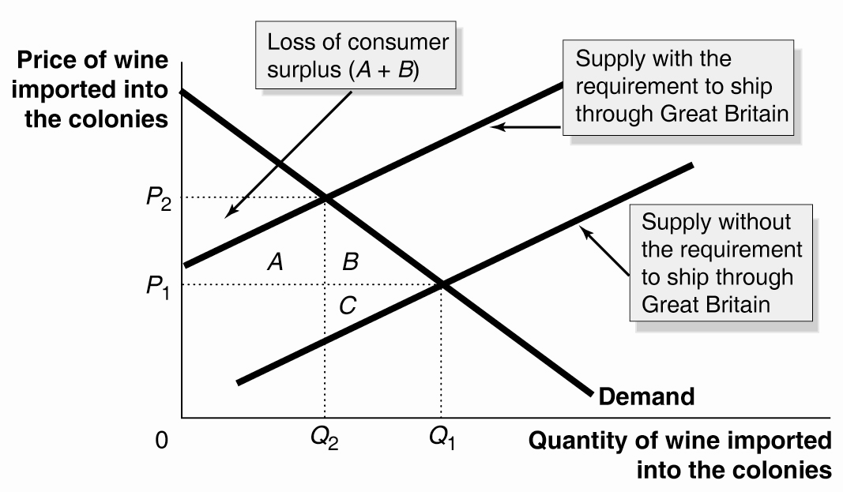

Step 3: Estimate the loss of consumer surplus and deadweight loss. The imposition of the Navigation Act restrictions on trade caused the supply curve to shift to the left. As a result, the equilibrium price was greater, and the equilibrium quantity less, than they would have been in the absence of the restrictions. Areas A and B represent the loss of consumer surplus. Part of this area – area A – is transferred to producers in the form of higher revenue from selling Q₂: (P₂ – P₁) x Q₂ . There is an overall gain in producer surplus (area A is larger than area C). But areas B and C indicate the deadweight loss, a net efficiency loss compared to the competitive equilibrium price and quantity (P₁ and Q₁). Robert Paul Thomas has estimated that loss of consumer surplus was $605,000 in 1770. Since the total income of the Colonies was only $130 million in 1770 the loss of consumer surplus was the equivalent of about $47 billion in today’s economy.

Source: Robert Paul Thomas, “A Quantitative Approach to the Study of the Effects of British Imperial Policy on Colonial Welfare,” Journal of Economic History, Vol. 25, No. 4, December 1965, pp. 615-38
CHAPTER 4 Appendix
Quantitative Demand and Supply Analysis

Demand and Supply Equations
1. Quantitative analysis supplements the use of demand and supply curves with equations.
An example of the demand and supply for apartments in New York City is
- Q^{D} = 3,000,000 – 1,000P
- Q^{S} = – 450,000 + 1,300P
- Q^{D} and Q^{S} are the quantity demanded and quantity supplied of apartments, respectively.
- At the competitive market equilibrium, quantity demanded equals quantity supplied.
    - Q^{D} = Q^{S} or
    - 3,000,000 – 1,000P = – 450,000 + 1,300P
    - Rearranging terms and solving for P yields the price at which quantity demanded equals the quantity supplied: the equilibrium price.
    - 3,000,000 + 450,000 = 1,300P + 1,000P
    - 3,450,000 = 2,300P
    - P = $1,500
- Substituting the equilibrium price into the equation for either demand or supply yields the equilibrium quantity.
    - Q^{D} = 3,000,000 – 1,000(1,500)
    - Q^{D} = 3,000,000 – 1,500,000
    - Q^{D} = 1,500,000
2. The demand equation can be used to determine the price at which the quantity demanded is zero.
- Q^{D} = 3,000,000 – 1,000P
- 0 = 3,000,000 – 1,000P
- –3,000,000 = –1,000P
- P = (–3,000,000)/(–1,000)
- P = $3,000
3. The supply equation can be used to determine the price at which the quantity supplied equals zero.
- Q^{S} = –450,000 + 1,300P
- 0 = –450,000 + 1,300P
- 450,000 = 1,300P
- P = $346.15
►Teaching tips: The equations highlight an oddity of demand and supply analysis that is lost on students unless they have a solid background in mathematics. The dependent variable in most graphs is the “Y variable,” the variable measured along the vertical axis, while the independent or “X variable” is measured along the horizontal axis. Economists assume that price changes cause changes in quantity, so the dependent variable appears on the left hand side of the demand and supply equations. In turn, the coefficient of the price terms in these equations equals the change in quantity divided by a one unit change in price (ΔQ/ΔP). But price appears on the vertical axis and quantity on the horizontal axis in demand and supply diagrams. You may wish to emphasize that the constant terms in the equations are not the vertical intercepts of the demand and supply curves and the coefficients of the price terms cannot be interpreted at the slopes of these curves.
Calculating Consumer Surplus and Producer Surplus
1. Demand and supply equations can be used to measure consumer and producer surplus. Figure 4A-1 illustrates the demand and supply equations in graph form.
- Consumer surplus equals the area under the demand curve above the equilibrium price.
- Because the demand curve is linear, consumer surplus is equal to the area of the blue triangle in Figure 4A-1.
- The area of a triangle is ½ multiplied by the base of the triangle multiplied by the height of the triangle.
- ½ x (1,500,000) x (3000 – 1,500) = $1,125,000,000
- Consumer surplus for rental apartments in New York City is about $1.125 billion.
- Producer surplus is the triangle above the supply curve in Figure 4A-1.
- The area of the triangle is
- ½ x (1,500,000) x (1,500 – 346) = $856,500,000
- Producer surplus for rental apartments in New York City is about $ 856 million.
2. The impact of a rent ceiling established at $1,000 can be estimated using the demand and supply equations.
- The quantity supplied of apartments at the ceiling price is
- Q^{S} = –450,000 + (1,300 x 1,000)
- Q^{S} = –450,000 + 1,300,000 = 850,000
- For a quantity of 850,000, the price on the demand curve is
- 850,000 = 3,000,000 – 1,000P
- 850,000 – 3,000,000 = - 1,000P
- –2,150,000 = –1,000P
- P = $2,150
3. Figure 4A-2 illustrates the changes in consumer surplus and producer surplus from the imposition of the rent ceiling.
- Area A ($500 x 850,000 = $425,000,000) is transferred from producer to consumer surplus.
- The gain in consumer surplus is partially offset by the loss of consumer surplus equal to area B.
- ½ x (1,500,000 – 850,000) x (2,150 – 1,500)
- ½ x 650,000 x 650 = $211,250,000
- Area B is a deadweight loss
- Producer surplus is reduced by area A plus area C. Area C equals
- ½ x (1,500,000 – 850,000) x (1,500 – 1,000)
- ½ x 650,000 x 500 = $162,500,000
- Area C is a deadweight loss
4. The calculations illustrated in Figure 4A-2 can be used to compute dollar values for the impact of rent control.
- Consumer surplus increases by area A ($425,000,000) minus area B ($211,250,000) = $213,750,000.
- Producer surplus decreases by area A ($425,000,000) plus area C ($162,500,000) = $587,500,000.
- The deadweight loss equals area B ($211,250,000) plus area C ($162,500,000) = $373,750,000.
►Teaching tips: Many students are inclined to believe rent ceilings are justified because they “protect the poor” from paying the equilibrium price. The above analysis does not allow one to determine which consumers are able to rent the 850,000 apartments. One could argue that these apartments are not likely to be rented to a disproportionate number of poor tenants. However, the deadweight loss is unambiguous: both consumers and producers suffer a loss of economic efficiency when only 850,000 rather than 1,500,000 apartments are rented.

5. Solutions to Review Questions and Problems and Applications

Answers to Thinking Critically Questions

1. Rent control encourages neglect of buildings. Due to excess demand, landlords know they can rent out the apartments even if they are in bad shape, so they see little point in spending money to maintain them. Neglecting maintenance will reduce the cost of apartments, shifting the supply curve to the right. It will also reduce consumers’ willingness to pay, shifting the demand curve to the left. Both of these actions will reduce the amount of the shortage and, paradoxically, bring the market closer to the efficient level of output than it would be if rent control existed but maintenance wasn’t reduced. Although the market is closer to the efficient level of output, there is a decline in product quality.

2. Even a fan of rent control would eventually change his mind as the costs rose and the benefits fell. For example, in the long run, rent control will induce more and more landlords to take their apartments off the market, causing a larger and larger shortage. In this case, overall consumer surplus to tenants will fall. (This can be seen in Figure 4-8. When the quantity supplied falls by enough, the gain to consumers in rectangle A will shrink to become smaller than the loss to consumers in triangle B.) Supporters of rent control may not equally weigh the well-being of each individual involved. For example, they may care only about consumers because they hate landlords. Or they may care only about the gains to themselves and not care about the losses to landlords and other consumers.

Answers to Review Questions

1. Marginal benefit is the additional benefit to a consumer from consuming one more unit of a good or service. The demand curve shows consumers’ willingness to pay for a product. The amount that they are willing to pay will equal the extra benefits they will receive from consuming it, thus the demand curve equals the marginal benefit curve for consumers.

2. Marginal cost is the additional cost to a firm of producing one more unit of a good or service. Supply curves show the willingness and ability of firms to supply a product at different prices. The willingness and ability to supply a product depends on the cost of producing it. The lowest price a firm is willing and able to accept is the additional cost of making the good, thus the supply curve equals the marginal cost curve.

3. Consumer surplus is the difference between the highest price a consumer is willing and able to pay and the price the consumer actually pays. As the equilibrium price falls, consumer surplus grows both because the gap between the willingness and ability to pay and price grows and because more is purchased. As the price rises, consumer surplus shrinks.

4. Producer surplus is the difference between the lowest price a firm would have been willing and able to accept and the price it actually receives. As the equilibrium price of the good rises, producer surplus rises. As the price falls, producer surplus falls.

5. Economic efficiency occurs when the marginal benefit to consumers of the last unit produced is equal to its marginal cost of production, and where the sum of consumer surplus and producer surplus is maximized. Economists define economic efficiency this way, because when it occurs, society puts its resources to their highest valued uses.

6. Some consumers gain from price controls because they can buy the product at a lower price, but others lose because they can no longer buy the product.

7. Producers tend to favor price floors that are set above the equilibrium price, but only if producer surplus rises – as would be the case when the price rises a lot but sales don’t fall much. Producers tend to loathe price ceilings that are set below equilibrium because sales fall and the price received falls, shrinking producer surplus.

8. A “black” market is one in which buyers and sellers violate government price regulations. A “black” market will arise if there are gains to some buyers and some sellers from violating a price floor or price ceiling.

9. Economic analysis will allow one to see the tradeoffs involved from imposing price ceilings and price floors, but it won’t provide a final answer to the appropriateness of the policy because people differ about the goals of such policies. Some people may have the goal of maximizing economic surplus, for example, but others may care mostly about the well-being of certain consumers or producers and care less about the well-being of other consumers or producers.

10. Tax incidence refers to the actual division of the burden of a tax – how much the tax pushes up the price paid by the buyers in comparison to how much it pushes down the price received by the sellers. The person who officially sends the tax revenue to the government need not be the one who actually pays the tax. For most taxes, the seller sends the money to the government, but buyers and sellers both pay part of the tax. The share paid by each depends on the shapes of the supply and demand curves.

Answers to End of Chapter Problems and Applications

1. a. 28 million crates
b. a surplus of 6 million crates
c. The apple growers will benefit. Their revenue will increase from $8 x 30,000,000 = $240,000,000 to $10 x 28,000,000 = $280,000,000.

2. a. The equilibrium quantity is 100 million crates of kumquats per year and the equilibrium price is $20 per crate. Kumquat producers receive revenue of $2 billion.

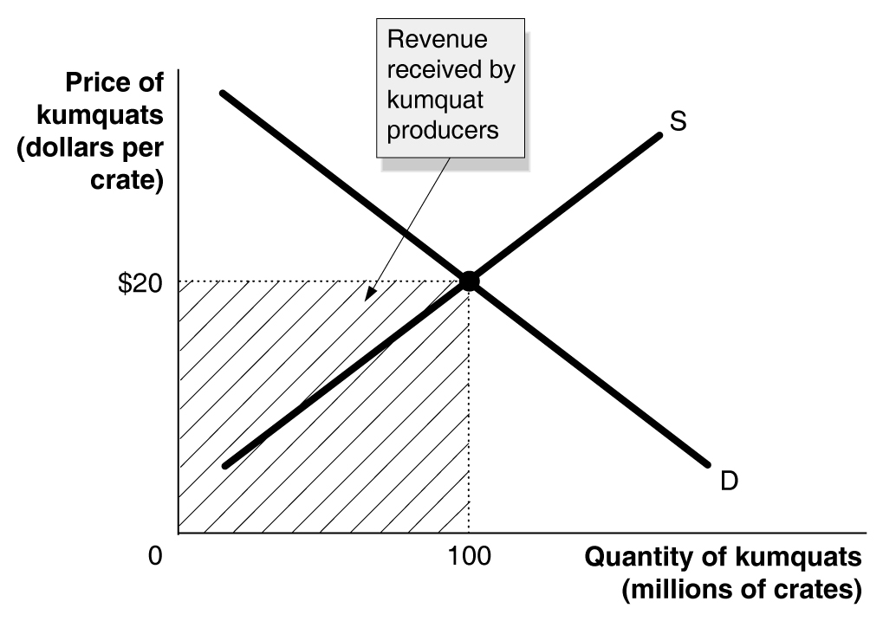

b. Consumers will purchase 80 million crates of kumquats. Kumquat producers receive revenue of $2.4 billion.

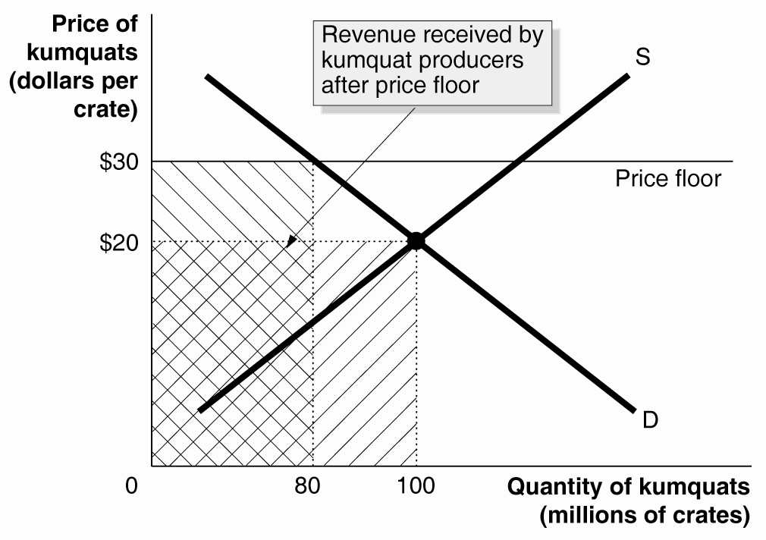

c. Kumquat producers will receive the revenue in b. plus $30 x 100 million crates, for a total of $5.4 billion. The government will spend $3 billion purchasing the 100 million crates of surplus kumquats.

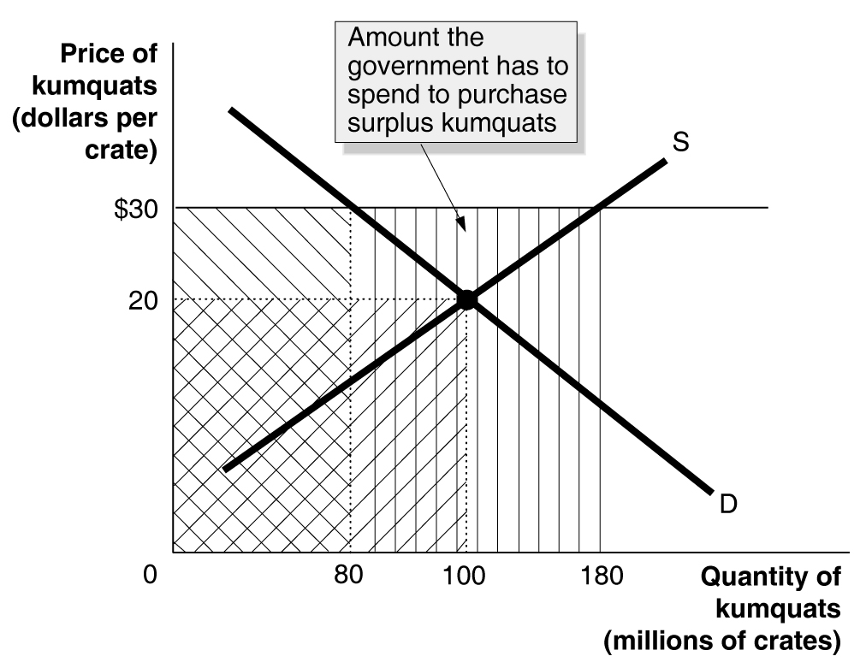

3. a. P_{E} is the competitive equilibrium price. P_{F} is the price floor. Q₁ is sold in competitive equilibrium. Q₂ is the amount sold with the price floor.
b. Economic surplus without a price floor = A + B + C + D + E. Economic surplus with price floor = A + B + D.

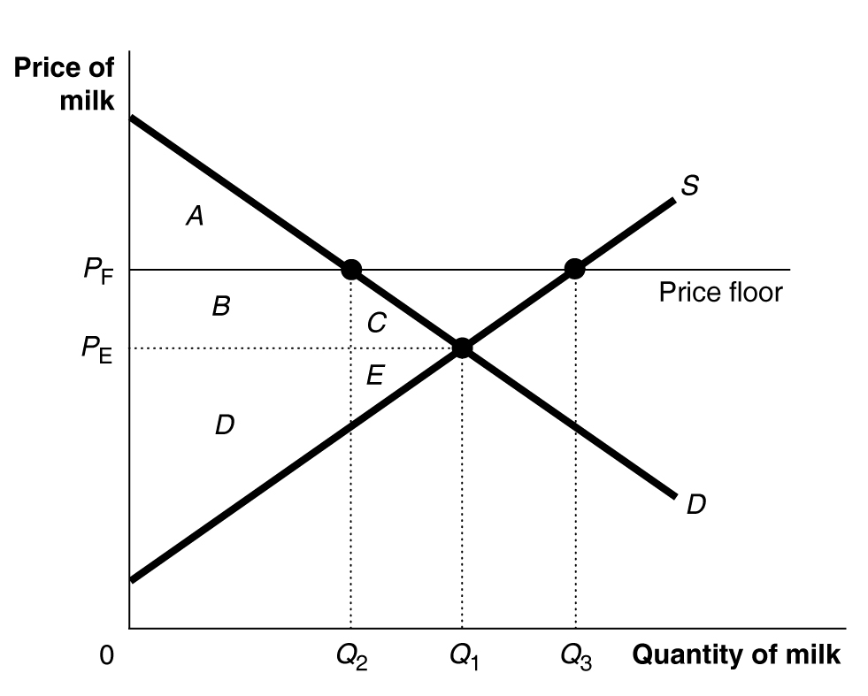

4. a. As the supply curve shifts inward from S₁ to S₂, consumer surplus will decrease from A + B + C + D to A.
b. Producer surplus will change from E + F + G to B + E. This may be an increase or a decrease, depending on the size of B relative to F + G.
c. Total surplus will fall from A + B + C + D + E + F + G to A + B + E.

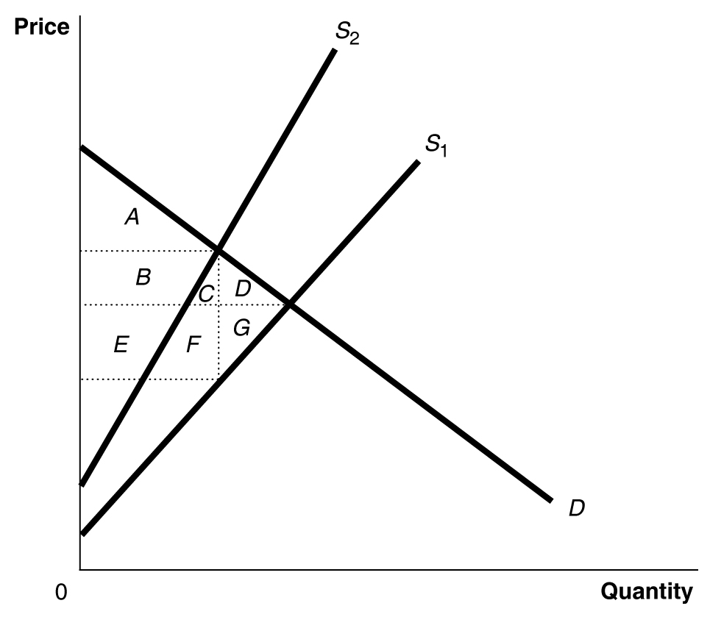

5. a. Price = $20, Quantity = 100,000
b. Price = $30, Quantity = 73,122
c. With no medallion requirement, consumer surplus = A + B + C, and producer surplus = D + E + F.
d. With the medallion requirement, consumer surplus = A, producer surplus = B + D + F, and deadweight loss = C + E.

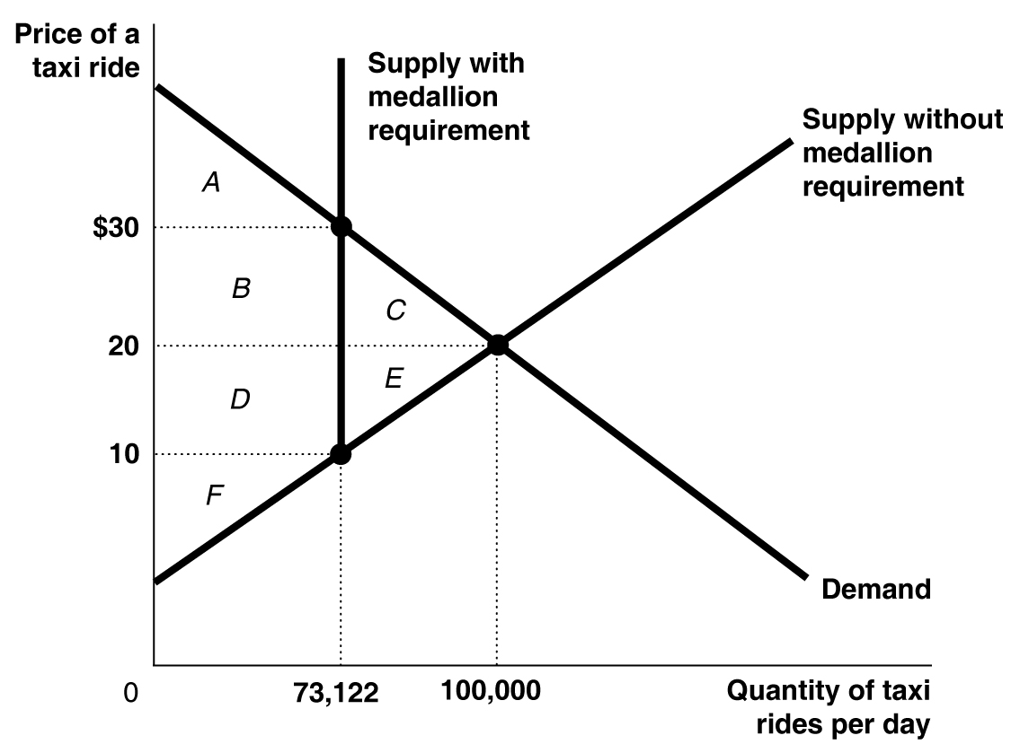

6. Under the current program, farmers receive subsidy payments whether they are rich or poor, and rich farmers are likely to receive more payments. One alternative would be for the government to give subsidies only to farmers whose incomes would otherwise be below a certain level.

7. The rent control law will push the price down from $600 to $500, creating a shortage equal to Q₁ – Q₂, since only Q₂ apartments will be supplied at $500. The layoffs will shift the demand curve inward from D₁ to D₂, which will cause the shortage to shrink. If the demand curve shifts in far enough, the rent ceiling law will become irrelevant and there will be no shortage because the new equilibrium price will be below $500 as shown in the figure. Q₃ will be the new equilibrium quantity.

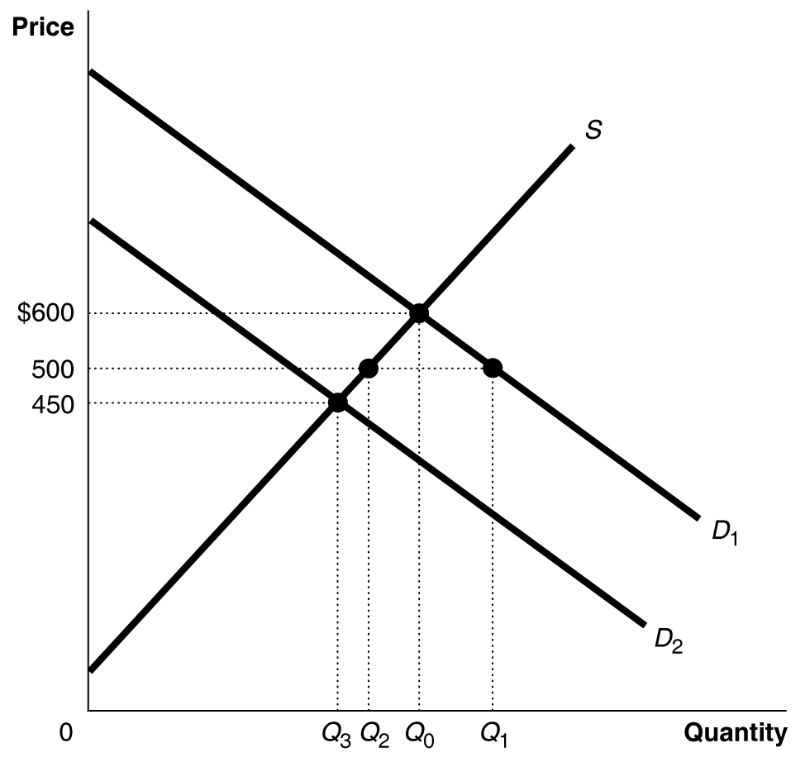

8. a. In the absence of rent control, the equilibrium price is $800 and the equilibrium quantity is 300,000. In this case, every renter who is willing to pay the market price of $800 will find an apartment and every landlord willing to accept the market price of $800 will find a renter. The demand and supply curve are shown in the figure, along with the equilibrium price (P_{E}) and quantity (Q_{E}).
b. At a price ceiling of $600, the quantity demanded is 350,000 but the quantity supplied is only 250,000, so there is a shortage of 100,000 apartments.
c. If all landlords abide by the law, the quantity sold will fall to 250,000. As shown in the figure, consumer surplus with the price ceiling enforced is A + C, producer surplus is E, and deadweight loss is B + D.
d. If landlords supply only 250,000 apartments and ignore the price ceiling, they can charge $1000. This is the amount that renters are willing to pay for the 250,000th apartment.

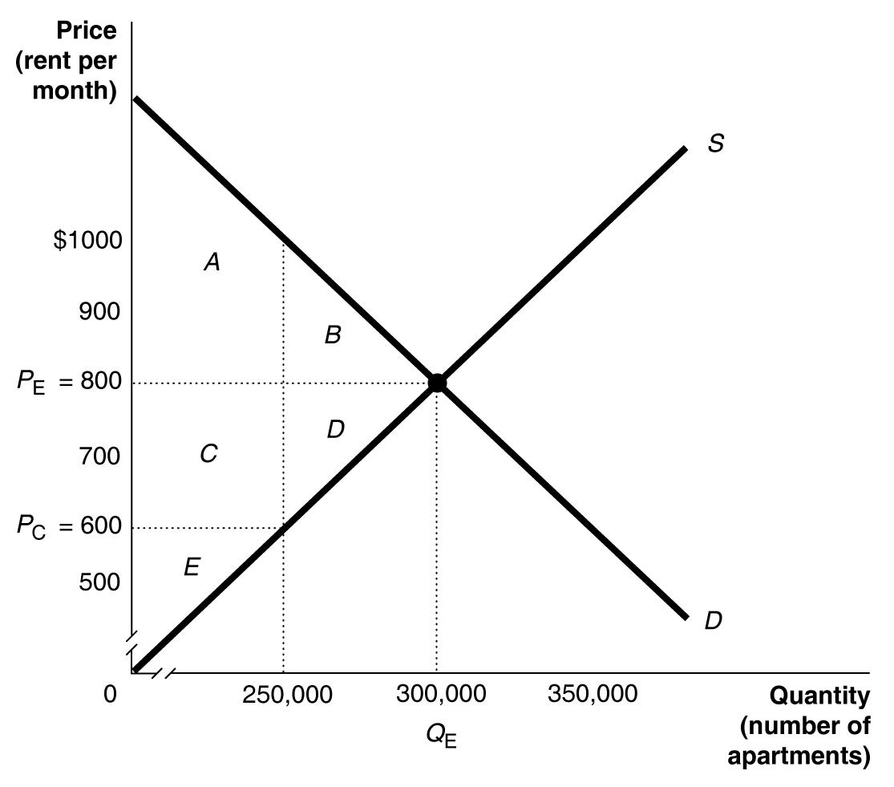

9. A “blacklist” of “high-risk” renters is more likely to exist in a city with rent control. With rent control in place, there is a shortage of apartments and each landlord has many renters hoping to get the apartment, so landlords can be very choosy about renters. If there were a list of high-risk renters in a non-rent-control city, it is likely that these renters could get an apartment by agreeing to pay a bit more than the going price, but in rent control cities it is illegal to charge more.

10. The statement is correct.

11. The first sentence of the student’s argument is correct. The second sentence is incorrect. A price ceiling increases the quantity that consumers demand, but because it also reduces the quantity that sellers supply, it reduces the amount of the product that consumers are actually able to buy. In the graph, without a price ceiling, consumers buy Q₁, with a price ceiling consumers buy only Q₂.

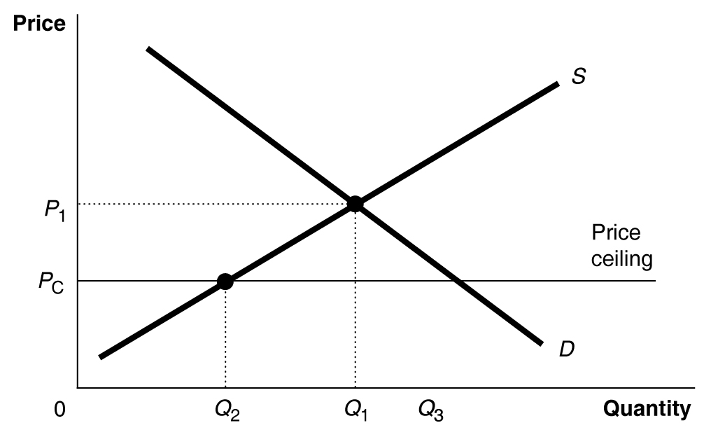

12. The advocate’s reasoning is incorrect. A fall in price will increase the quantity of kidney transplants demanded, but not the demand for kidney transplants. Although the price ceiling will increase the quantity demanded, the quantity supplied will fall, and fewer kidney transplants will occur. In the graph, without a price ceiling, patients receive Q₁ kidney transplants, and with a price ceiling, patients receive only Q₂.

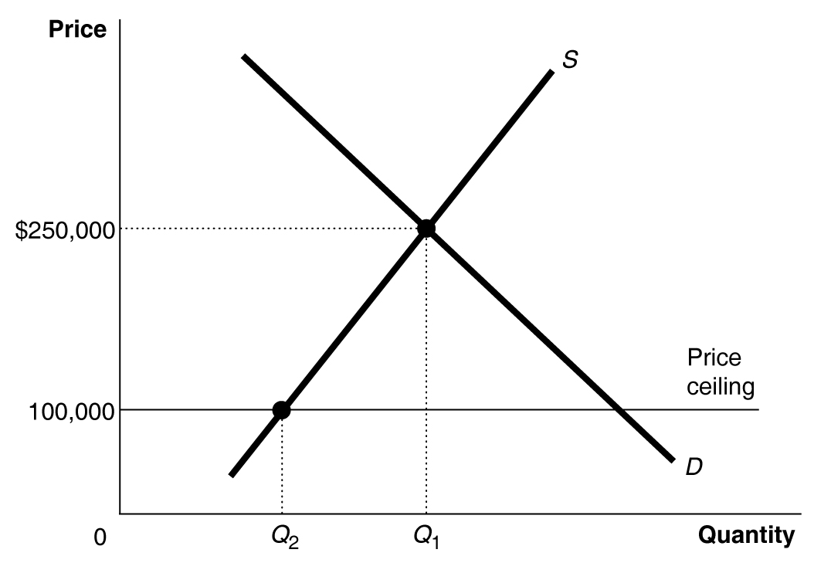

13. Some of the renters who lose their apartments in Woburn will look for apartments in Peabody. This will shift the demand curve in Peabody from D₁ to D₂, which will cause both an increase in quantity and price in Peabody.

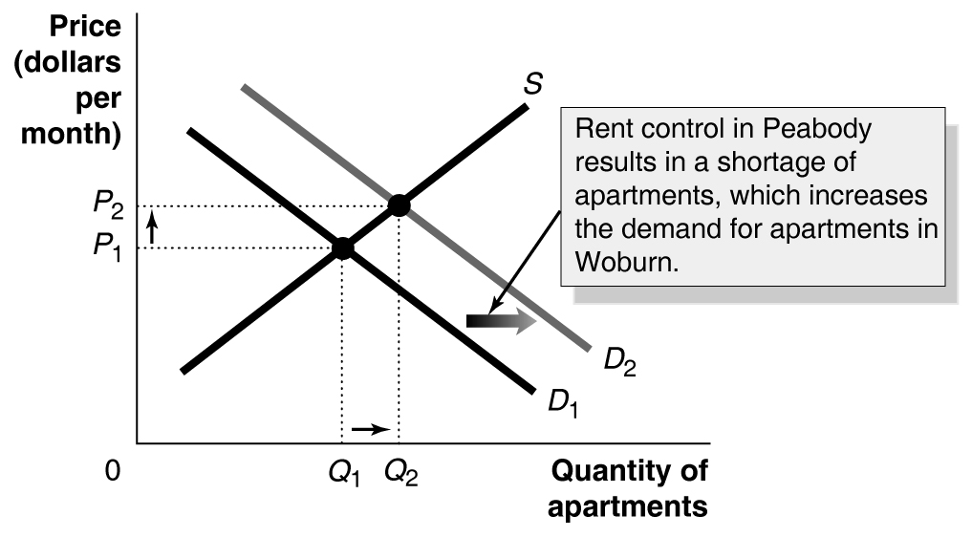

14. The people who benefit from rent controls are politically powerful and have resisted seeing them abolished.

15. Whether cities should enact rent controls is a normative question. Rent controls may help some people, but hurt others – those who can’t find any apartment to rent. Rent controls clearly create a shortage of rental units and a disincentive for landlords to spend on maintenance, since the landlords know that they don’t need to keep the units well maintained because there are many eager renters hoping to fill any vacancy.

16. a. With no price ceiling, the equilibrium price of gasoline would be $3.00 per gallon and the quantity demanded and quantity supplied would both be 40 million gallons per month. With a price ceiling and no black market, the price of gasoline is $2.00 per gallon, the quantity demanded is 45 million gallons, the quantity supplied is 30 million gallons, and there is a shortage of 15 million gallons.
b. Consumer surplus = A + B + C, producer surplus = D, and deadweight loss = E + F.
c. Consumer surplus = A, producer surplus = B + C + D, and deadweight loss = E + F.

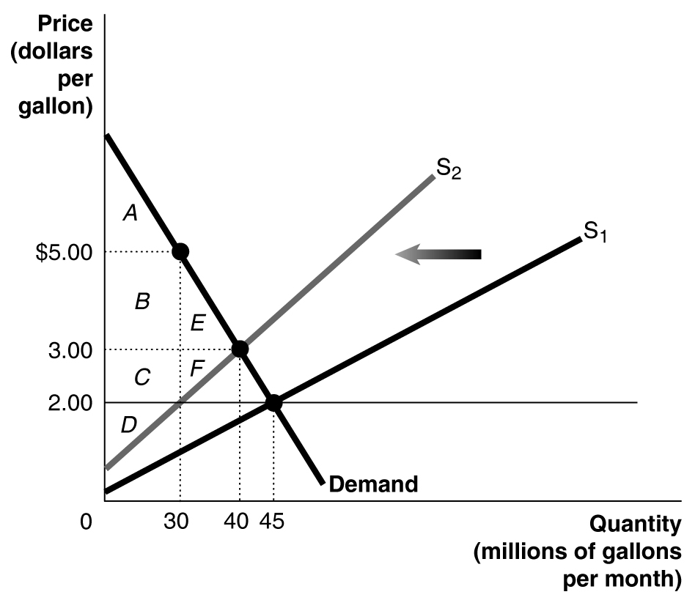

d. They are, at least in the short run, as long as a black market does not develop, because their consumer surplus with the price ceiling is A + B + C, but without the ceiling it would be only A + B + E. (C is larger than E. E’s area is 0.5 x 10,000,000 x $2.00 = $10,000,000, while C = $1.00 x 30,000,000 = $30,000,000.)

17. The main beneficiaries are small and inefficient retailers who would not be able to match the discounts large and efficient retailers would offer if the law allowed them to. Consumers and large retailers lose as a result of this law.

18. For many years the family farm was considered the social and moral backbone of the country. This may account for the special help family farmers receive from the government. (Alternatively, it may be because states with a lot of family farms are disproportionately represented in the U.S. Senate.)

19. a. If you are currently a renter, the law will probably make you better off, unless you are one of those whose landlord removes his apartment from the market.
b. Worse off, since you’ll probably not be able to find a vacant apartment.
c. Worse off.
d. Better off, unless you get caught and the penalty is large.

20. a. The tax equals $1.25. This is the vertical distance between the two supply curves.
b. Producers receive $2.50 from consumers but keep only $1.25 after paying the tax to the government.
c. Tax revenue = $1.25 x 18 billion = $22.5 billion.

21. This reasoning is incorrect. Although the industry is competitive, its demand curve slopes downward and its supply curve slopes upward, like most other industries. Thus, as shown in the figure, the tax will be split between the buyers and sellers. The tax shifts the supply curve inward from S₁ to S₂. The price paid by the buyers rises from P_{E} to P_{B}, while the after-tax price kept by the suppliers falls from P_{E} to P_{S}. P_{B} – $1 = P_{S}.

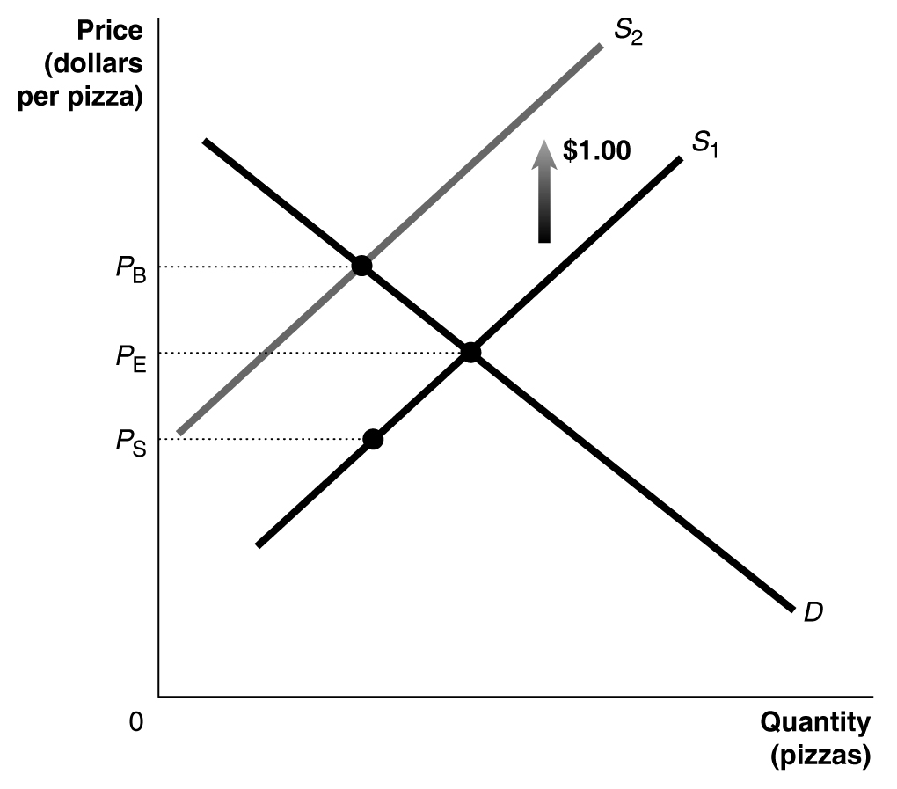

22. If the demand curve is correct, the consumer surplus is infinite, because the willingness to pay is infinite – unlike the other markets we’ve studied. (It’s pretty much impossible for the demand curve to be vertical forever, however, because no one has an infinite amount of money to spend.)

23. The producer surplus in this market is a rectangle, rather than a triangle (as is typical in most markets). The producer surplus equals P x 15,000, so all of the revenue is producer surplus because the marginal cost of supplying the concert is zero.

24. If you could accurately measure it (a difficult task), economic surplus (the sum of producer and consumer surplus) would be a great indicator of the well-being generated from economic activity, since it sums up all the value created from economic activity. The most economically efficient country would have the highest amount of total surplus.

Answers to Appendix Review Questions

1. In a linear demand equation, the intercept on the price axis tells the price at which the quantity demanded is zero. No one is willing to pay this price or above for the product.

2. The price that maximizes total surplus is the equilibrium price. At this price there is no deadweight loss.

3. Consumer surplus measures net benefit by subtracting the price paid from the total benefits received from the good or service.

4. Deadweight loss is an interesting turn of phrase. It measures the loss of surplus, the gains to consumers and producers that could have easily been realized but were “killed” by the price control (or some other policy). The deadweight loss drags us away from efficiency like a heavy “weight” pulling the economy down.

Answers to Appendix Problems and Applications

1. The equilibrium wage can be found by setting L^{D} equal to L^{S} and solving for W.
100 – 4W = 6W, so 100 = 10W, and W = $10. The labor surplus equals L^{S} – L^{D} at the minimum wage. Plugging $12 into the supply equation: L^{S} = 6 x 12 = 72. Plugging $12 into the demand equation L^{D} = 100 – (4 x 12) = 52. Thus the surplus is 72 – 52 = 20.

2. The minimum wage will have the larger impact in the top figure. Because its demand curve is so flat (elastic), employers will reduce the quantity of labor demanded considerably more than in the bottom figure.

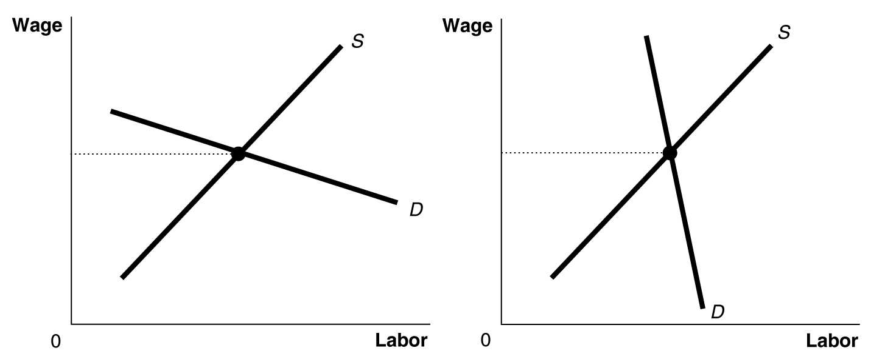

3. The equilibrium price is $20 and the equilibrium quantity is 5. The consumer surplus is A in the figure, whose area is 0.5 x 5 x $2.50 = $6.25. The producer surplus is B, whose area is 0.5 x 5 x $5 = $12.50.

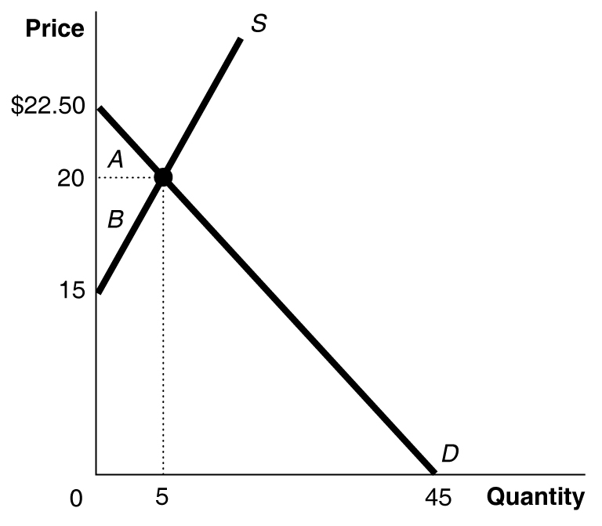

4. a. Deadweight loss = C + E. C = 0.5 x $1 x 10,000 = $5000. E = 0.5 x $1 x 10,000 = $5000.
b, c, and d. Consumer surplus without the price floor is A + B + C, and with the price floor remaining, consumer surplus is A. Producer surplus without the price floor is D + E + F, and with the price floor it is B + D + F. Thus area B of consumer surplus is transferred from consumers to producers. B = $1 x 10,000 = $10,000. D = $1 x 10,000 = $10,000.

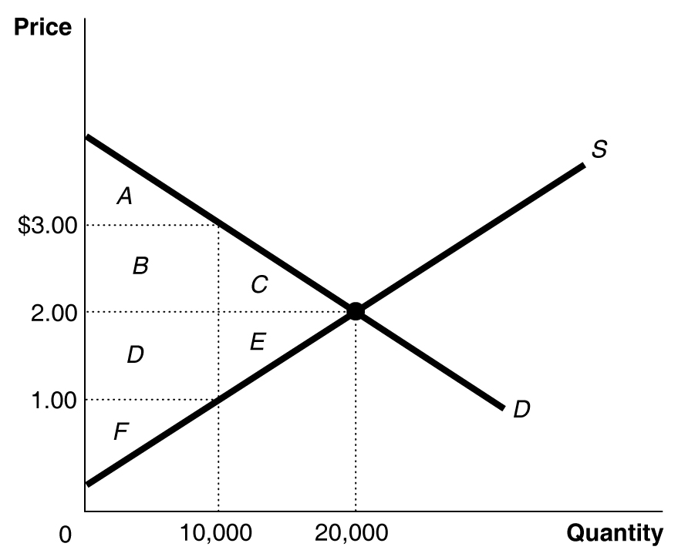

5. The totals are in millions of dollars.
Consumer Surplus |  | Producer Surplus |  | Deadweight Loss
Competitive Equilibrium | Rent Control | Competitive Equilibrium | Rent Control | Competitive Equilibrium | Rent Control
$1,125 | $1,381.95 | $865.50 | $473.97 | $0 | $134.55

With a price ceiling of $1200, the quantity supplied will be -450,000 + (1300 x 1200) =
-450,000 + 1,560,000 = 1,110,000. The willingness to pay can be found from the demand equation. Set Q^{D} equal to 1,110,000 and solve for price. 1,110,000 = 3,000,000 – 1000P, so 1000P = 1,890,000 and P = $1890. Consumer surplus under rent control equals A + B + D, producer surplus equals F, and deadweight loss equals C + E.
Area A = 0.5 x ($3000 - $1890) x 1,110,000 = $616,050,000
Area B + D = ($1890 - $1200) x 1,110,000 = $765,900,000, so
Consumer surplus = A + B + D = $1,381,950,000
Area C + E = 0.5 x ($1890 - $1200) x (1,500,000 – 1,110,000) = $134,550,000 = deadweight loss.
Area F = 0.5 x ($1200 - $346) x 1,110,000 = $473,970,000.

